A case study for Building Advanced Windows Phone Applications

* 1. Welcome to the case study for Building Advanced Windows Phone Applications, Connecting with Cloud Services.

# Introduction

This project updates the Windows® Phone 7.0 Guidance published on MSDN at [Windows Phone 7 Developer Guide](http://msdn.microsoft.com/en-us/library/gg490765.aspx) to the Windows Phone 7.1 SDK, while at the same time reducing the written guidance down to a case study of the Tailspin mobile client application. This case study will also examine and provide additional guidance for unit testing Windows Phone applications.

This project and the written guidance have been renamed to a case study for Building Advanced Windows Phone Applications.

The key themes for these projects are:

* A Windows Phone client application, written using the Windows Phone 7.1 SDK
* A Windows Azure backend for the system
* Unit testing for Windows Phone client applications

# Target Audience

* 1. This guidance is part of a series on Windows Azure service and client application development. However, it is not limited to only applications that run in Windows Azure. Windows Phone applications can interact with almost any service—they use data exposed by any on-premises or remote service. Even if you are building applications for Windows Phone that use other types of services (or no services at all), this guidance will help you to understand the Windows Phone environment, the development process, and the capabilities of the device.
  2. This guidance is intended for any architect, developer, or information technology (IT) professional who designs, builds, or operates applications and services for Windows Phone. It is written for people who work with Microsoft® Windows-based operating systems. You should be familiar with the Microsoft .NET Framework, Microsoft Visual Studio® development system, and Microsoft Visual C#®. You will also find it useful to have some experience with Microsoft Expression Blend® design software and the Microsoft Silverlight® browser plug-in, although this is not a prerequisite.

# Knowledge Requirements

* 1. This project makes heavy use of Reactive Extensions and developers will need to understand them in order to understand the guidance in this project. The following links will help you understand and learn Reactive Extensions:
* [Reactive Extensions (Rx) Home Page](http://msdn.microsoft.com/en-us/data/gg577609)
* [Reactive Extensions Team Blog](http://blogs.msdn.com/b/rxteam/)
* [Mike Taulty’s Reactive Extensions “for the rest of us” (Part 1)](http://mtaulty.com/CommunityServer/blogs/mike_taultys_blog/archive/2011/05/03/reactive-extensions-for-the-rest-of-us-devdays-holland-part-1.aspx)
* [Mike Taulty's Reactive Extensions “for the rest of us” (Part 2)](http://mtaulty.com/CommunityServer/blogs/mike_taultys_blog/archive/2011/05/03/reactive-extensions-for-the-rest-of-us-devdays-holland-part-2.aspx)

# Installation

## Overview

To install and run the Tailspin mobile client implementation, you must perform the following steps:

1. Verify system requirements
2. Extract the code from the MSDN download center or CodePlex
3. Add the post extraction requirements to the solution folder
4. Open the TailSpin.PhoneOnly.sln or TailSpin.sln solution
5. If you open the TailSpin.PhoneOnly.sln, change the build configuration to “OnlyPhone”
6. Run the solution

## Step 1: System Requirements

* + Microsoft Windows Vista® operating system (x86 and x64) with Service Pack 2 (all editions except Starter Edition) or Microsoft Windows 7 (x86 and x64) (all editions except Starter Edition)
  + Microsoft Visual Studio 2010 Professional, Premium, or Ultimate edition
  + [Microsoft Visual Studio 2010 SP1](http://www.microsoft.com/downloads/en/details.aspx?FamilyID=75568aa6-8107-475d-948a-ef22627e57a5&displaylang=en)
  + [Windows Phone 7.1 SDK](http://www.microsoft.com/download/en/details.aspx?displaylang=en&id=27570)

## Step 2: Extract the Code

* After downloading the zip file, you must “unblock” the zip file before extracting it.
* Right click on zip file, select “Extract All…”
* Click “Extract” button.

## Step 3: Add Post Extract Requirements to Solution Folder

* + Run CheckDependencies.cmd
    - Note: if the DependencyChecker does not successfully enable Windows Communications Foundation in IIS, please enable it manually.   
      To enable WCF, open Control Panel, click on **Programs**, under **Programs and Features** click on **Turn Windows features on or off**. In the Windows Features dialog box, expand **Microsoft .NET Framework 3.5.1** and click the checkbox to enable **Windows Communications Foundation HTTP Activation**.
  + [Silverlight for Windows Phone Toolkit](http://silverlight.codeplex.com/releases/view/75888)
    - Please copy the Silverlight for Windows Phone Toolkit to the   
      “\Lib\Silverlight for Windows Phone Toolkit” folder as shown below.

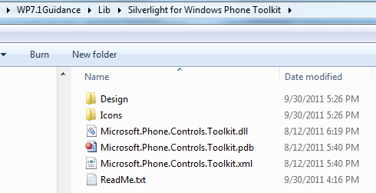

* + [Silverlight Unit Testing for Windows Phone with Jeff Wilcox's fixes](http://www.jeff.wilcox.name/2011/06/updated-ut-mango-bits/)
    - After downloading, you must “unblock” the zip file before extracting it.
    - Please copy the Silverlight Unit Testing for Windows Phone with Jeff Wilcox’s fixes to the “\Lib\SilverlightUnitTestingFramework” folder as shown below.

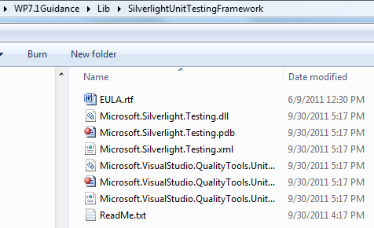

## Step 4: Open TailSpin.PhoneOnly.sln

## Step5: Change Build Configuration to “OnlyPhone”

* 1. 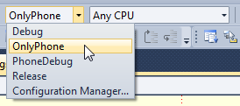

## Step 6: Run Solution

On first run, you you’ll need to configure your application settings. You must use: fred, joe, or scott for the user name. The password field is required but it’s not validated.

## Getting Started

To see surveys on the phone, you should create new surveys on the local web site first. To do this, visit <https://127.0.0.1:444/> which shows certificate error, click Continue to this web site, click either Adatum or Fabrikam, login then Click New Survey tab and create surveys. This site will be available if you run the full solution. It should show when you run debug.

If you want to change the location where the phone get's the surveys, you can change the address in ContainerLocator.cs in the phone project.

There are two solutions included with the source drop. The TailSpin.Phone.sln (Phone Solution) only uses a mock version of the server components. The TailSpin.sln includes all the projects including the Azure components.In the Phone Solution, we only support the OnlyPhone build configuration. The reason for this is we are sharing that project between the two solutions. If you build the OnlyPhone build you will get a debug build with mock services. If you build debug or release, the project will try and go against the local dev fabric and fail (if it is not running).

# Known Issues

* 1. When launching the Surveys cloud application from TailSpin.sln, you will be presented with a certificate error when launching the TailSpin.Web role. This is expected and you should click the "Continue to this website (not recommended)" link to fully launch the role.

1. 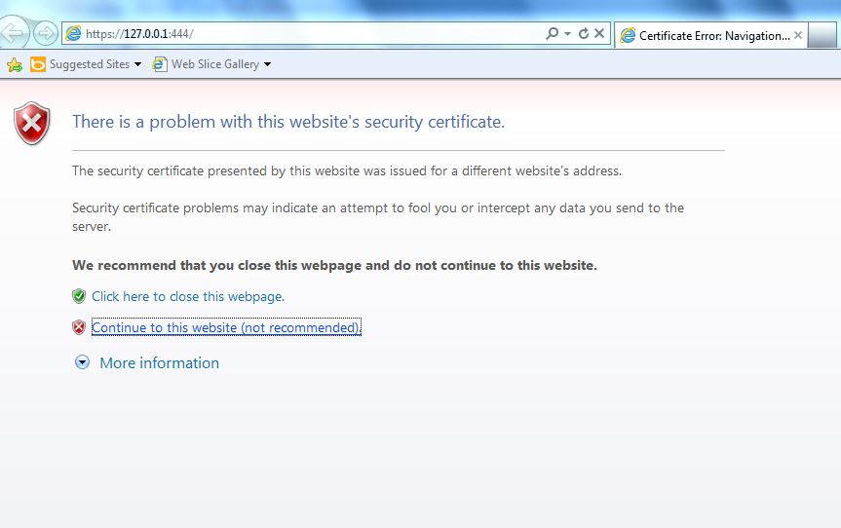
   1. Tailspin does not currently do anything in the event that a push notification is received while the application is in the foreground.
   2. Background tasks are scheduled only when the application closes. The tasks are not scheduled when the application is deactivated.
   3. Tailspin deletes the temporary files related to completed voice and picture questions. However, if the application goes to dormancy before the user saves the completed voice and picture questions, the temporary files related to the voice and picture questions are orphaned and are not deleted from isolated storage by the application.
   4. Surveys in the Favorites pivot do not persist between application launches.
   5. The ScheduledAction does not handle SchedulerServiceExceptions. A SchedulerServiceException gets thrown when the Scheduled Action Service encounters an internal error. For example, when the Scheduled Action Service is not ready, such as within one minute after device boot.
   6. When the progress indicator is displayed the application does not provide the user with the option to cancel the operation being performed.
   7. Voice recording stops when a phone call occurs. However, recording continues when the application resumes from dormancy.

Repro:

* Start a voice recording and then receive a phone call. When the application resumes once the phone call is over, recording occurred until the moment the phone call was received.
* Start a voice recording, press the home button, and then press the back button to return to the application. The application continues to record once it has resumed. Therefore, recording occurs all the time except for when the application was in dormancy.

# Feedback Welcome

* 1. The Windows Phone Guidance Team welcomes all feedback. Project’s community site is <http://wp7guide.codeplex.com>. There, you can post questions, provide feedback, or connect with other users for sharing ideas.